**MORNING STAR SCHOOL**

**ACADEMIC SESSION 2024-25**

**SUMMER HOLIDAY HOMEWORK**

***Class-X***

**GENERAL INSTRUCTIONS**

⭐The assignment should be done as per the instructions given.

⭐It should be neatly labelled with your name, class and section mentioned clearly.

⭐The last date of submission of holiday assignment is 5thJuly 2024.

⭐Students are requested to do a lot of reading of books related to their stream & newspapers.

⭐ Prepare yourself for the Periodic Test-I which is going to be held in the month of July.

**Holiday homework is intended to make students independent and enhance their skills and capabilities. Holiday homework helps to keep students on track and keep their brains ticking.**

**Subject:-ENGLISH**

1. In your Grammar registers write the meaning of the following literary devices along with 2 examples each:

- Analogy

- Anaphora

- Assonance

- Allusion

- Enjambment

- Personification

- Hyperbole

- Imagery

- Simile

- Alliteration

- Repetition

- Inversion

- Allusion

- Poetic License

**Make your work colorful**

2. Have you ever been in great difficulty and felt that only a miracle could help ? Write about this in 100-120 words on your grammar registers.

3. Revise all the lessons taught in the month of April.

4. Write about your favorite poet in about 100 words.

5. Form a word tree out of the word 'establish'. At least15 more words.

6. Select any four 'Parts of Speech ' and describe them in detail. Make your work colourful.

- Noun

- Pronoun

- Verb

- Adjective

- Adverb

- Preposition

- Conjunction

- Interjection

**NOTE:- Your entire Holiday Home Work should be done in your grammar register.**

**Subject:-HINDI**

1- कबीरदास जी का जीवन परिचय देते हुए उनकी रचनाओं का सचित्र वर्णन कीजिए।

2- छायावाद की स्तंभ महादेवी वर्मा का परिचय देते हुए उनकी कविताओं का सचित्र वर्णन कीजिए।

3-हरिवंश राय बच्चन का जीवन परिचय देते हुए उनकी मुख्य- मुख्य कविताओं का सचित्र वर्णन कीजिए।

4-रस क्या है उनके प्रकारों का सचित्र वर्णन कीजिए।

**प्रश्न 2-लघु कथा लिखिए--**

1- परोपकार

2- सच्ची मित्रता

3- हार जीत

**नोट- 1परियोजना कार्य में से किसी एक विषय पर कार्य करना है।**

2-लघु कथा तीनों ही करना है।

**Subject:-SCIENCE**

**CHEMISTRY**

**1) NCERT solutions chapter 1**

**2) Project based on chapter 1**

**Q1. According to the following Ray diagrams.**

**Explain the terms which are given below for each case.**

(a) Nature of image

(b) Size of image

(c) Position of image

(d) Is image real or virtual

**\*Draw these Ray diagram 10 x times each.\***

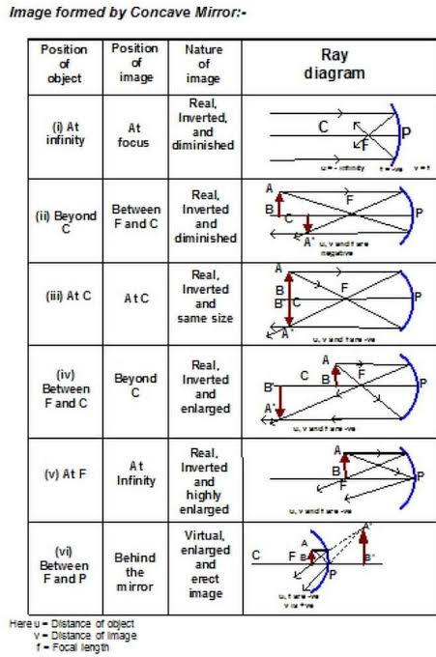

Q**2. Draw the following Ray diagrams 10 times each case.**

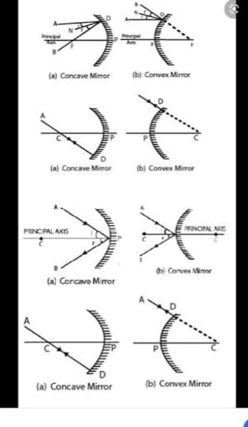

**BIOLOGY**

**Writing :**

1. Complete the notes of chapter 1 Life process

2. Complete the NCERT question and answer in fair notebook. Chapter1 Life process.

3. Complete the given worksheet:

I. Why do herbivores have longer small intestine as compared to carnivores?

II. Write the balanced chemical equation for the process of photosynthesis. How photosynthesis occur in desert plants?

III Explain the process of nutrition in Amoeba.

IV. Draw neat diagram of alimentary canal of human being.

V. How do guard cells regulate the opening and closing of the stomata?

VI. State the role of the following in human digestive system:

(a). Digestive enzymes. (b)Hydrochloric acid. (C). Villi.

**LEARNING:**

I. Important terms, very short question answer, short question answer, long answer of chapter 1 Life process

**PRACTICE:**

Do practice of diagrams given in the chapter 1 Life process :

1. Alimentary canal of human being.

2. Closing and opening of stomata.

3. Human respiratory system.

**Subject:-MATHEMATICS**

1.  For what value of k, (–4) is a zero of the polynomial x2 – x – (2k + 2)?

2.  For what value of p, (–4) is a zero of the polynomial x2 – 2x – (7p + 3)?

3.  If 1 is a zero of the polynomial p(x) = ax2 – 3(a – 1) x – 1, then find the value of a.

4.  If (x + a) is a factor of 2x2 + 2ax + 5x + 10 find a.

5 Write the zeroes of the polynomial x2+ 2x + 1.

6 Write the zeroes of the polynomial x2 – x – 6.

7.   Write a quadratic polynomial, the sum and product of whose zeroes are 3 and –2 respectively.

8.  Write the number of zeroes of the polynomial y = f(x) whose graph is given in the figure.

  Find the zeroes of the quadratic polynomial 6x2 – 3 – 7x and verify the relationship between the zeroes and the coefficient of the polynomial.

9.  Find the zeroes of the quadratic polynomial 5x2 – 4 – 8x and verify the relationship between the zeroes and the coefficient of the polynomial.

10.  Find the quadratic polynomial, the sum of whose zeroes is 8 and their product is 12. Hence, find the zeroes of the polynomial , If one zero of the polynomial (a2 – 9) x2 + 13x + 6a is reciprocal of the other, find the value of ‘a’.

11.  If the product of zeroes of the polynomial ax2 – 6x – 6 is 4, find the value of ‘a’.

12.  Find all the zeros of the polynomial x4 + x3 – 34x2 – 4x + 120, if two of its zeroes are 2 and – 2.

13.  Find all the zeroes of the polynomial 2x4 + 7x – 19x2 – 14x + 30, if two of its zeroes are

14.  Find the quadratic polynomial whose zeroes are 1 and –3. Verify the relation between the coefficients and the zeroes of the polynomial.

15.  Find the zeroes of the quadratic polynomial 4x2 – 4x – 3 and verify the relation between the zeroes and its coefficients.

16.  Find all the zeroes of x4 – 3x3 + 6x – 4, if two of its zeroes are

17..  Find a quadratic polynomial whose zeroes are –4 and 3 and verify the relationship between the zeroes and the coefficients.

18.  Using division algorithm, find the quotient and remainder on dividing f(x) by g(x), where f(x) = 6x3 + 13x2 + x – 2 and g(x) = 2x + 1

19.  If the polynomial 6x4 + 8x3 + 17x2 + 21x + 7 is divided by another polynomial 3x2 + 4x + 1 then the remainder comes out to be ax + b, find ‘a’ and ‘b’

20.  If the polynomial x4 + 2x3 + 8x2 + 12x + 18 is divided by another polynomial x2 + 5, the remainder comes out to be px + q. Find the value of p and q.

21.  Find all the zeroes of the polynomial 2x3 + x2 – 6x – 3, if two of its zeroes are –

22.  If α and β are zeroes of the quadratic polynomial x2 – 6x + a; find the value of ‘a’ if 3α + 2β = 20.

**Subject:-SOCIAL SCIENCE**

**Locate and Labeling Maps**

**( HISTORY )**

• Nationalism in India

- List of Area

I. Congress sessions:

‌1920 Calcutta

‌1920 Nagpur.

‌1927 Madras session,

**2 Satyagraha movements:**

‌Kheda

‌Champaran.

‌Jallianwala Bagh

‌Dandi march

**GEOGRAPHY**

**• Resources and Development**

‌Salal

‌Bhakra Nangal

‌Tehri

‌Rana Pratap Sagar

‌Sardar Sarovar

‌Hirakund

‌Nagarjuna Sagar

‌Tungabhadra

**• Agriculture**

- Major areas of Rice and Wheat

‌Largest/ Major producer states of Sugarcane, Tea, Coffee, Rubber, Cotton and Jute

• Minerals and Energy Resources

**a. Iron Ore mines**

‌Mayurbhanj

‌Durg

‌Bailadila

‌Bellary

‌Kudremukh

**b. Coal Mines**

‌Raniganj

‌Bokaro

‌Talcher

‌Neyveli

**c. Oil Fields**

‌ Digboi

‌Naharkatia

Thermal Power Plant

‌Namrup

‌Singrauli

‌Ramagundam

**d. Nuclear Power Plant**

‌Narora

‌Kakrapara

‌Tarapur

‌Kalpakkam

**Manufacturing Industries**

**( Cotton Textile Industries)**

a. Mumbai

b. Indore

c. Surat

d. Kanpur

e. Coimbatore

**( Iron and Steel Plants)**

a. Durgapur

b. Bokaro

c. Jamshedpur

d. Bhilai

e. Vijayanagar

f. Salem

**Lifelines of National Economy**

**a. ( Major sea ports)**

‌Kandla

‌Mumbai

‌Marmagao

‌New Mangalore

‌Kochi

‌Tuticorin

‌Chennai

‌Vishakhapatnam

‌Paradip

‌Haldia

**b. (International Airports)**

‌Amritsar (Raja Sansi - Sri Guru Ram Dass jee)

‌Delhi (Indira Gandhi)

‌Mumbai (Chhatrapati Shivaji)

‌Chennai (Meenam Bakkam)

‌Kolkata (Netaji Subhash Chandra Bose)

‌Hyderabad (Rajiv Gandhi)

**Subject:-ECONOMICS**

1. What may be development for one, may not be development for another, Explain the statement with suitable examples?

2. Write a short note on HDI.

Q. Write the meaning of development.

Q. What is HDI?

Q. How to calculate average income?

**Subject:-COMPUTER**

* Write notes with diagram on following topic:- (ASSIGNMENT FILE ) (minimum 2 Pages required for each topic)
* Emerging technology
* Programming with Python
* Importance of Computer in space research
* Write about Alan Turning, Father of Computer Science And Artificial Intellegence. (ASSIGNMENT FILE )
* Write 10 HTML program with their output (ASSIGNMENT FILE )

**\*ACTIVITY RECOMMENDED DURING VACATION\***

* Meditate and do simple yoga exercises .
* Water plants and feed the birds.
* Join your grandparents and parents for their morning walk.
* Help your mother in the kitchen .
* Don’t watch too much of television .
* keep your environment in surrounding clean .
* Plant trees and conserve your natural resources.
* Build and improve your vocabulary through crosswords, jumble words etc.
* Solve riddles and puzzles.
* Read story books and visit places.
* Improve your reading and writing skills by reading and writing.

**Note:**

* **Summer breaks are from 5th May to 23 June 2024. The school will**

**reopens on 24th June 2024**

***Have a great***

***Summer Vacation***